AFFIDAVIT OF IDENTITY THEFT
I, Devon Jermaine Dunham, being of lawful age and competent to testify, declare under penalty of perjury that I am the individual whose personal identifying information is referenced in this affidavit, that I have personal knowledge of the matters stated herein except where otherwise indicated, and that this affidavit is submitted to document identity theft, unauthorized use of my personal identifying information, and disputed items appearing in consumer reporting and related records.
Declaration
I declare that the statements set forth below are true and correct to the best of my knowledge, information, and belief. I have repeatedly requested that soft inquiries be removed from my profile, but each bureau has the conveyance that “it is typical to see small variations in reported personal information like names and addresses and that soft inquiries do not affect your credit score or profile.” However, ambiguity within this data allows multiple credit profiles that belong to the same person to have hidden accounts with identical account numbers from the same creditor with mis-matching information such as balance and payment history which is different at each bureau and is directly related to the real name true-identity theft I am experiencing.
Throughout this affidavit will show accounts with disparate information from different profiles with data that has changed overtime from each credit report summary or dispute results report.
Except where expressly identified as authorized by me, the addresses, aliases, accounts, inquiries, and related activity described in this affidavit were not initiated, opened, authorized, or benefited by me.
Statement of Facts
- I have been identified by other credit bureaus as a victim of real-name true identity theft by Equifax, Transunion, and Consumerinfo.COM. I dispute every name other than Devon Jermaine Dunham and address other than 925 SW 35th Street Lawton, OK or 1530 PB LN Wichita Falls, TX 76302, Social Security Variation, Employer, Collection and other records listed in any bureau.
- The address 927 SW 35th Street, Lawton, Oklahoma 73505, should not be associated with my profile. It first appeared through an SSN Tracker Alert on TransUnion on 11/28/2020, and again on 3/4/2022, 3/4/2024, 6/28/2025, and 9/5/2025 without my authorization or knowledge. I was informed that this address was linked to Merrick Bank, but it appears to be associated with other accounts opened fraudulently.
- 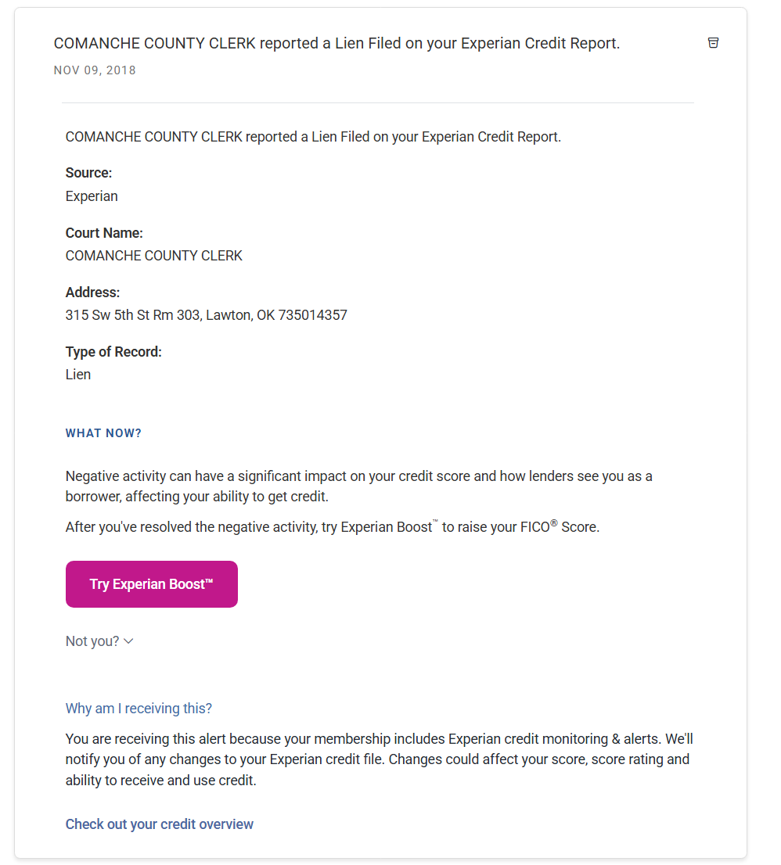
  - I contacted the county clerk regarding the record depicted above and did not receive a response. Upon reviewing the tax liens and releases on file, I observed discrepancies including incorrect amounts, mismatched warrants, a materially different document format or template, and a missing record.
  - As of 5/20/2026, The name Devon J. Dunham has re-appeared on my Experian report. The name Devon Dunham is now also showing on latest “dispute results”, while Devon J. Dunham shows on the “Print Your Report", and finally, Devon Jermaine Dunham, my true identity shows on the summary. Every alias is fraudulent along with the accounts listed within that profile.
An Experian alert dated 1/23/2026 stated, “Ran SSN against credit report data,” and listed the following aliases and addresses that I dispute:
    - Devon J Dunham
    - Devon J Dunhm
    - Devon Dunhm
    - Devon Dunham
    - 927 Sw 35th St, Lawton, OK 73505
    - 1530 P B Ln, Wichita Falls, TX 76302
    - 1530 Pv Ln Apt D9144, Lawton, TX 76302
    - 1316 Nw Sheridan Rd, Lawton, OK 73505
    - 4413 121st Ln, Lubbock, TX 79424
    - 370 Us Highway 87, Lubbock, TX 79423
    - 7007 Sw Stradford Ave Apt B, Lawton, OK 73505
    - 9404 Northland Rd, Oklahoma City, OK 73120
`
  - Items to be removed from Devon Jermaine Dunham Profile:
    - SELENE FINANCE LP - 271200XXXXXXX - $61,959
    - 1ST DIGITAL/SYNOVUS/VT - 526449XXXXXX
    - CAPITAL ONE - 517805XXXXXX - $238
    - CONN APPLIANCES INC - 515205XXX - $1,139
    - ELAN FINANCIAL SERVICE –
    - NATIONSTAR/MR COOPER - 631992XXX - $45,000
    - TBOM/MILESTONE - 549806XXXXXX - $700
    - TOTAL VISA/TBOM/VT - 405731XXXXXX - $328
    - LVNV FUNDING LLC - 526449XXXXXXXXXX - $386
    - SOUTHWEST RECOVERY SER - SWRS21XXXX - $750
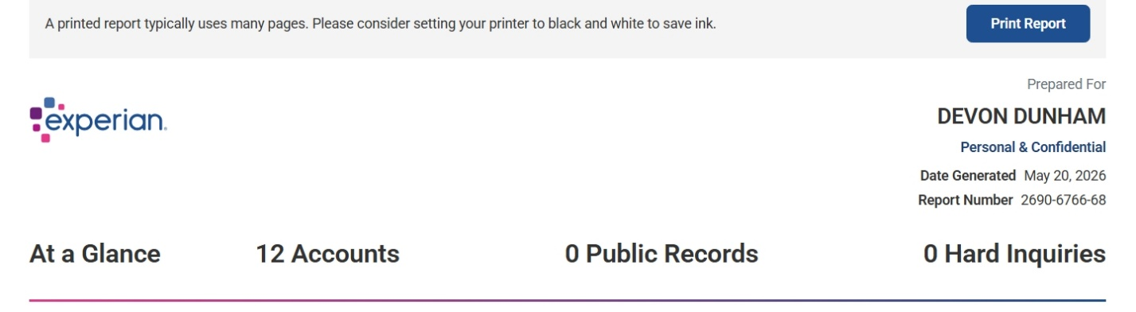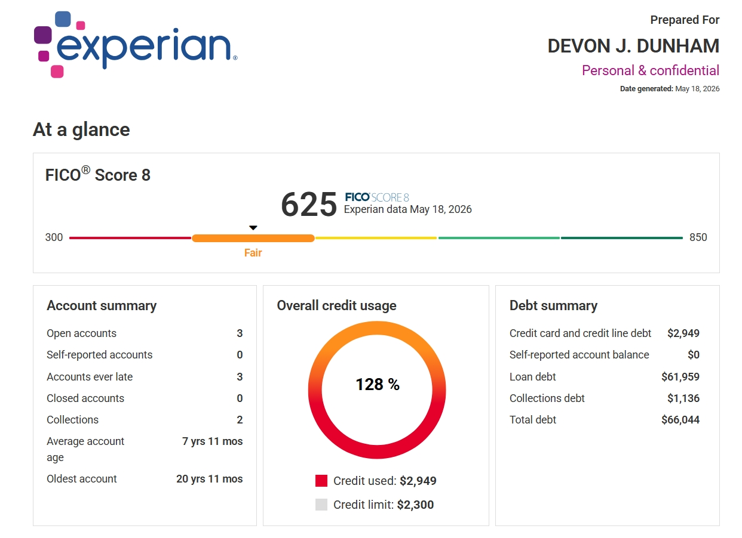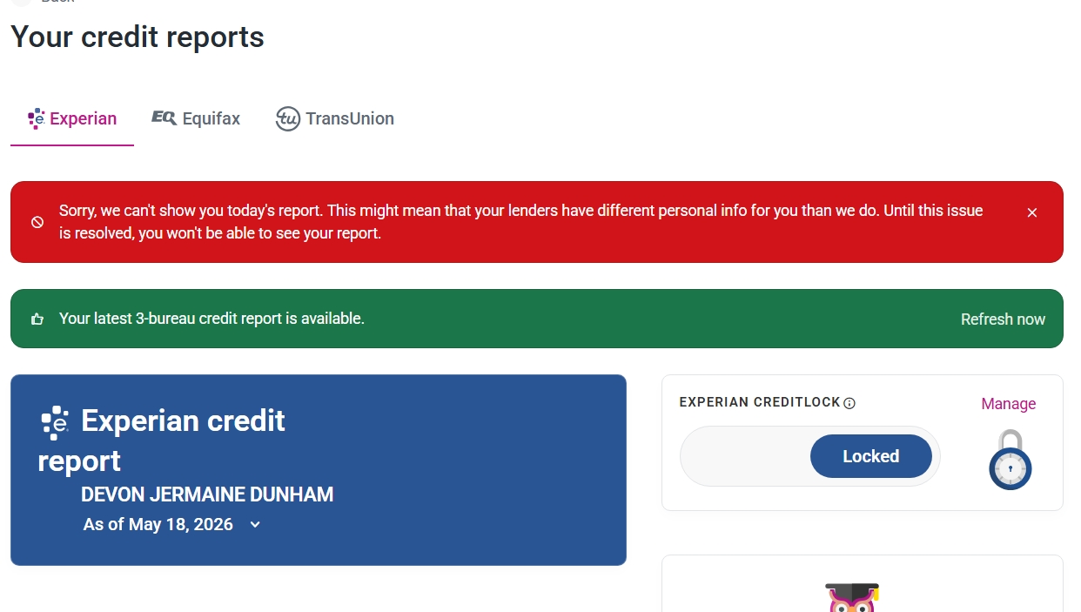
- On 1/23/2026, Experian reflected inquiries and loans not shown on my standard credit report and stated, “We searched for alternative lending activity under your personal info.” The screenshots and records below are incorporated as supporting documentation for this statement.
- Exhibit #1 – ALERT I PH/EXPERIAN
Inquired on 02/21/2026 and 02/06/2026
701 Experian Pkwy, Allen TX 75013
(888) 397-3742
On behalf of 5802846839
- Exhibit #2 – AMERICAN EXPRESS
Inquired on 05/20/2025
5301 McConnell Rd, Whitsett NC 27377
(800) 874-2717
- Exhibit #3 – CAPITAL ONE
Inquired on 03/07/2026
15000 Capital One Dr, Richmond VA 23238
- Exhibit #4 – CAP ONE NA
Inquired on 05/30/2025
1500 Capital One Drive, Richmond VA 23285
- Exhibit #5 – CAPITAL ONE
Inquired on 05/30/2025
15000 Capital One Dr, Richmond VA 23238
- Exhibit #6 – CLARITY/ADVANCE AMERICA
Inquired on 09/12/2025, 09/09/2025 and 03/31/2025
135 N Church St, Spartanburg SC 29306
- Exhibit #7 – CLARITY/ELK LENDING-TPSI
Inquired on 09/10/2025
W2818 Warrington Road, Keshena WI 54135
- Exhibit #8 – CLARITY/THREE STICKS LEN
Inquired on 03/31/2025
27565 Research Park Dr, Mission SD 57555
(844) 328-1024

- Exhibit #9 – CONSUMERINFO.COM
Inquired on 05/27/2025
475 Anton Blvd, Costa Mesa CA 92626
- Exhibit #10 – CONTINENTAL FINANCE COMP
Inquired on 08/20/2025, 07/18/2025, 06/25/2025 and 03/26/2025
4550 New Linden Hill Rd #400, Wilmington DE 19808
- Exhibit #11 – EXPERIAN
Inquired on 03/17/2026, 03/16/2026, 03/15/2026, 03/14/2026, 03/13/2026, 03/12/2026, 03/11/2026, 03/09/2026, 03/06/2026, 03/05/2026, 03/04/2026, 03/03/2026, 03/02/2026, 03/01/2026, 02/27/2026, 02/26/2026, 02/25/2026, 02/24/2026, 02/23/2026, 02/21/2026, 02/20/2026, 02/19/2026, 02/16/2026, 02/13/2026, 02/12/2026, 02/06/2026, 02/04/2026, 02/03/2026, 01/29/2026, 01/17/2026, 05/06/2025, 04/19/2025, 04/18/2025 and 04/17/2025
PO Box 9600, Allen TX 75013
(800) 311-4769
CAPS API DISCLOSURE
- Exhibit #12 – EXPERIAN
Inquired on 03/13/2026, 03/09/2026, 03/05/2026, 02/21/2026, 02/17/2026, 02/06/2026, 01/22/2026, 01/19/2026, 01/17/2026, 01/09/2026, 01/06/2026, 12/24/2025, 12/05/2025, 11/27/2025, 11/21/2025, 11/15/2025, 11/12/2025, 11/06/2025, 10/29/2025, 10/23/2025, 10/21/2025, 10/02/2025, 08/28/2025, 08/21/2025, 08/19/2025, 08/02/2025, 07/15/2025, 07/02/2025, 06/25/2025, 06/18/2025, 06/17/2025, 05/30/2025, 05/29/2025, 05/24/2025, 05/19/2025, 05/13/2025, 05/08/2025, 05/03/2025, 04/11/2025, 03/26/2025 and 03/19/2025
475 Anton Blvd, Costa Mesa CA 92626

- Exhibit #13 – EXPERIAN
Inquired on 03/09/2026, 03/05/2026, 02/23/2026, 02/12/2026, 02/09/2026, 02/06/2026, 02/05/2026, 02/04/2026, 02/03/2026, 02/01/2026, 01/30/2026, 01/29/2026, 01/28/2026, 01/26/2026, 01/25/2026, 01/23/2026, 01/19/2026, 01/17/2026, 01/12/2026, 01/11/2026, 01/05/2026, 12/29/2025, 12/22/2025, 12/15/2025, 12/08/2025, 12/01/2025, 11/24/2025, 11/17/2025, 11/10/2025, 11/03/2025, 10/27/2025, 10/13/2025, 10/08/2025, 10/06/2025, 09/29/2025, 09/22/2025, 09/17/2025, 09/15/2025, 09/12/2025, 09/09/2025, 09/08/2025, 09/03/2025, 09/02/2025, 09/01/2025, 08/31/2025, 08/29/2025, 08/27/2025, 08/26/2025, 08/25/2025, 08/18/2025, 08/17/2025, 08/14/2025, 08/11/2025, 08/09/2025, 08/04/2025, 08/03/2025, 07/30/2025, 07/29/2025, 07/28/2025, 07/26/2025, 07/24/2025, 07/16/2025, 07/15/2025, 07/14/2025, 07/10/2025, 07/09/2025, 07/08/2025, 07/06/2025, 07/05/2025, 07/02/2025, 06/30/2025, 06/29/2025, 06/26/2025, 06/23/2025, 06/22/2025, 06/20/2025, 06/17/2025, 06/16/2025, 06/15/2025, 06/14/2025, 06/13/2025, 06/12/2025, 06/09/2025, 06/03/2025, 06/02/2025, 05/30/2025, 05/29/2025, 05/26/2025, 05/20/2025, 05/19/2025, 05/15/2025, 05/12/2025, 05/09/2025, 05/06/2025, 05/05/2025, 04/28/2025, 04/21/2025, 04/19/2025, 04/18/2025, 04/17/2025, 04/16/2025, 04/15/2025, 04/14/2025, 04/07/2025, 03/31/2025, 03/24/2025 and 03/17/2025
475 Anton Blvd, Costa Mesa CA 92626
(866) 431-3471
- Exhibit #14 – EXPERIAN
Inquired on 02/06/2026
475 Anton Blvd, Costa Mesa CA 92626
- Exhibit #15 – EXPERIAN
Inquired on 05/27/2025
475 Anton Blvd, Costa Mesa CA 92626
- Exhibit #16 – EXPERIAN
Inquired on 05/27/2025
PO Box 9600, Allen TX 75013
(800) 311-4769

- Exhibit #17 – EXPERIAN CREDITMATCH
Inquired on 02/09/2026, 02/06/2026, 02/04/2026, 02/03/2026, 02/01/2026, 01/29/2026, 01/28/2026, 01/26/2026, 01/25/2026, 01/23/2026, 01/19/2026, 01/17/2026, 01/11/2026, 09/12/2025, 09/03/2025, 08/25/2025, 08/14/2025, 08/09/2025, 07/30/2025, 07/26/2025, 07/15/2025, 07/14/2025, 07/09/2025, 07/06/2025, 06/30/2025, 06/22/2025, 06/12/2025, 05/27/2025, 05/26/2025, 04/19/2025, 04/18/2025, 04/17/2025 and 04/15/2025
475 Anton Blvd # D4, Costa Mesa CA 92626
- Exhibit #18 – EXPERIAN CS IDENTITY
Inquired on 02/16/2026, 01/16/2026, 12/16/2025, 11/16/2025, 10/16/2025, 09/16/2025, 08/16/2025, 07/16/2025, 06/16/2025, 05/16/2025, 04/16/2025 and 03/16/2025
535 Anton Blvd Ste 100, Costa Mesa CA 92626
- Exhibit #19 – ID ME INC
Inquired on 06/14/2025
8281 Greensboro Dr Ste 600, Tysons Corner VA 22102
(866) 775-4363
- Exhibit #20 – INTUIT INC
Inquired on 02/24/2026
2700 Coast Ave, Mountain View CA 94043
- Exhibit #21 – NATIONAL FUNDING
Inquired on 07/30/2025
4380 La Jolla Village Dr, San Diego CA 92122
(888) 733-2383

- Exhibit #22 – NAV TECHNOLOGIES INC
Inquired on 03/06/2026, 03/05/2026, 02/21/2026, 02/18/2026, 02/16/2026, 02/13/2026, 02/06/2026, 01/22/2026, 01/19/2026, 01/09/2026, 01/06/2026, 12/17/2025, 12/05/2025, 11/27/2025, 11/06/2025, 10/29/2025, 10/08/2025, 09/27/2025, 08/19/2025, 08/18/2025, 08/12/2025, 08/02/2025, 06/18/2025, 05/30/2025, 05/19/2025, 05/08/2025, 04/18/2025, 03/26/2025, 03/21/2025, 03/19/2025 and 03/12/2025
13693 S 200 W Ste 200, Draper UT 84020
(855) 226-8388
- Exhibit #23 – NAV TECHNOLOGIES INC
Inquired on 03/24/2025
12936 S Frontrunner Blvd # 550, Draper UT 84020

- EXHIBIT #24 NOVO PLATFORM INC
Inquired on 02/26/2026
123 WILLIAMS ST, FL 19, NEW YORK NY 10038
(844) 260-6800

- Exhibit #25 – NOVO PLATFORM INC
Inquired on 09/24/2025, 08/26/2025, 07/22/2025, 06/24/2025 and 04/30/2025
123 Williams St, Fl 19, New York NY 10038
(844) 260-6800
COLLECTION

- Exhibit #26 – REPRISE FINANCIAL
Inquired on 07/29/2025, 07/01/2025 and 05/27/2025
PO Box 143454, Irving TX 75014
(855) 475-6767

- Exhibit #27 – RESURGENT CAPITAL SERVICE
Inquired on 04/08/2025
PO Box 10497, Greenville SC 29603
(866) 464-1183

- Exhibit #28 – SEEN FINANCE INC
Inquired on 08/05/2025, 07/10/2025 and 06/09/2025
1193 W 2400 S, West Valley City UT 84119
(833) 923-7336

- Exhibit #29 - ZILLOW INC
Inquired on 08/18/2025
1301 2ND AVE FL 36, SEATTLE WA 98101
(206) 470-7000

- Selene Finance LP is reported by Experian, while Equifax has deleted it as of 6/5/2026, but was showing Selene Finance LLC and TransUnion reports payment terms that do not match the modification documents along with mismatched balances, terms, dates and account numbers and was opened fraudulently using real name identity theft in an alias of Devon J. Dunham which is not my true identity. On 1/13/2026 it was stated via e-mail:

      - “According to your executed Loan Modification Agreement, effective April 1, 2024, the amountpayable under the Note and Security Instrument (the “new principal balance”) is $62,266.20.
This amount includes previously unpaid amounts, along with interest and other sums that were capitalized as part of the modification. Of this amount, $17,297.00 was deferred. The remaining portion represents the principal balance that is due and payable under the modified terms.

A copy of the executed Loan Modification Agreement is enclosed for your reference.
Please be advised that your account does not show any late fee balance. “
Yet, TransUnion shows a separate mortgage with a different account number totaling $470 per month for 40 months, but I have been getting charged $662, and I was still being charged a late fee the month of January and thereon even though it has been in dispute, and they have yet to provide the modification documents in the portal as I have requested until completing the CFPB.
- On January 18, 2020, a Liberty National Bank account was reported as being opened according to my Experian alerts. This was unbeknownst to me, and I did not apply for or authorize that account and have asked that the bank close it.
- On 1/23/2026, there were 66 items flagged from “Ran info against dark web,” but were displayed in a different profile than Devon Jermaine Dunham and should not be displayed and is evidence that my personal identifying information has been compromised.
- I am not responsible for the 27 or more OneMain inquiries identified in report 4939-7524-60. The 29 soft inquiries listed below are concerning because they appear related to unauthorized accounts and activity that do not belong to me and were opened fraudulently using real name identity theft and should not be shown in my real name or true identity. Exhibit #25 specifically needs to be removed as it was opened fraudulently in a different profile as well and shows to be a collection of corporate nature.
- I communicated with Experian concerning Dispute No. 194621928 to request removal of a disputed address, removal of a name alias, flagging of Nationstar, removal of four soft inquiries, and opt-out from prescreening but I continue to get inquiries from Experian.
- There has been a change in my Experian report in which Devon Jermaine Dunham shows as my real name and “true identity”. Every account listed was opened fraudulently as it was not opened using this profile and is shown in this profile because the bureau allowed it to be updated as such.

- Additional activity further supports my identity theft claim, including the following: (a) when I logged into Experian, a two-factor authentication text displayed a number that is not associated with my account; (b) after I evicted a renter and contacted the Lawton Police Department, my passport card was taken and a citation was issued containing mismatched personal identifying information and profile details I did not provide, followed by my discovery that a police report had been opened in my name on 3/11/2026 without my knowledge and was under investigation for fraud.
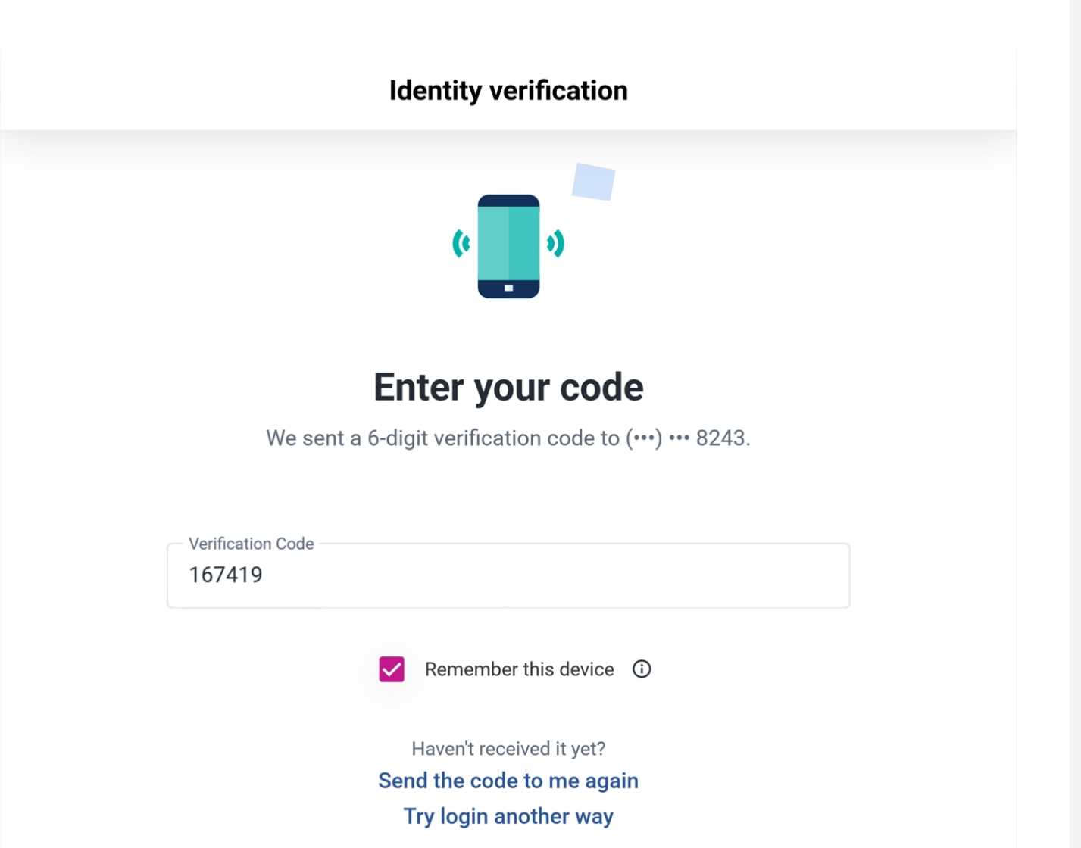

Relief Requested
- I request that all consumer reporting agencies, furnishers, creditors, and other relevant entities promptly block, remove, suppress, synchronize or otherwise cease reporting any account, tradeline, inquiry, alias, address, phone number, or other identifying information that is unauthorized, inaccurate, unverifiable, or the product of real name true-identity theft.
- I request correction and deletion of all disputed personal identifying information, including aliases, addresses, employers, collections, and contact information that do not belong to me or were associated with my profile without my authorization.
- I request a reasonable investigation and written validation from each entity that accessed, used, furnished, or relied upon my personal identifying information, including the basis for each inquiry, account opening, tradeline, or report entry reflected in the records attached to this affidavit.
- I request that any collection, servicing, lending, foreclosure or delinquent reporting activity related to disputed or unauthorized accounts be suspended or blocked pending investigation and resolution.
- I request written confirmation of all corrections, deletions, blocks, suppressions, fraud flags, and other remedial actions taken in response to this affidavit.
- I further request any other relief, protection, or corrective action available under applicable law to prevent additional misuse of my identity and to restore the accuracy of my consumer and related records.
Attestation
Further affiant sayeth not. I declare under penalty of perjury that the foregoing statements are true and correct to the best of my knowledge, information, and belief.
Executed on ____________________, 2026, at 6:59:45 PM
__________________________________
Devon Jermaine Dunham, Affiant
Subscribed and sworn to before me on ____________________, 20____.
__________________________________
Notary Public
My commission expires: ____________________

